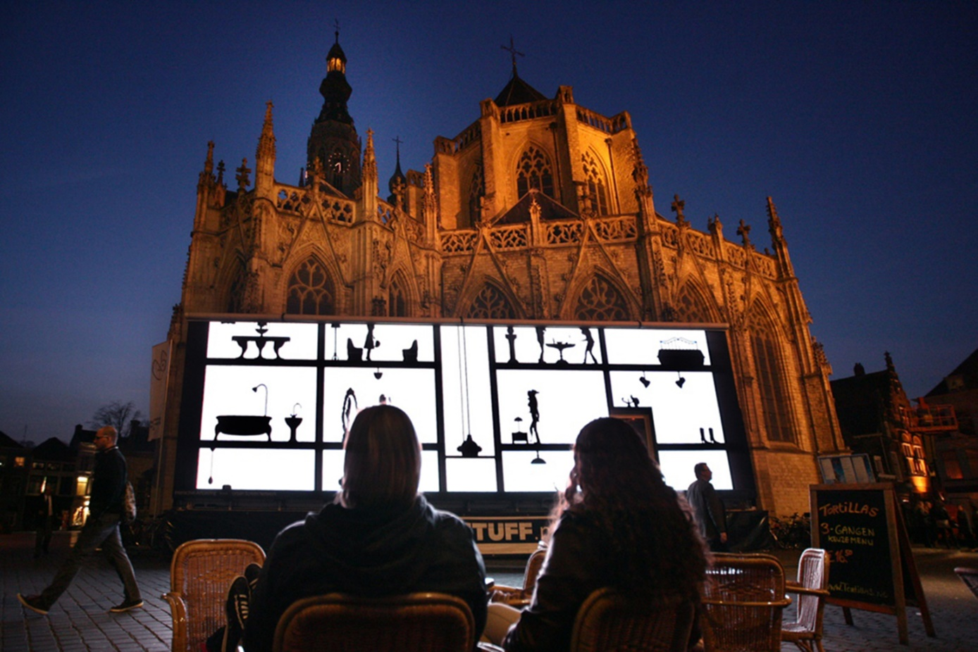
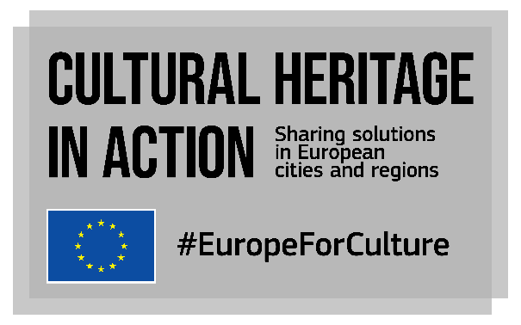
OPEN CALL FOR GOOD PRACTICES
A SPOTLIGHT ON YOUR WORK IN CULTURAL HERITAGE
are you working for a city, a region, a NON-URBAN or a rural area? SHARE YOUR GOOD PRACTICES!
Deadline 15 October 2022

Sharing your best practice
We want to share your best practices throughout Europe and beyond. If you are part of the administration of a city, region or a rural area in the EU, this is your chance to highlight your work in cultural heritage. All you need to do is fill out a short form with a description of a practice in your area. About 30 practices will then be selected for publication and promotion through the EU-funded Cultural Heritage in Action programme.

Interested?
Carefully read this document. Once your application is ready, send it out to culturalheritageinaction@eurocities.eu If you have any questions or doubts, do not hesitate to contact us at the same address.

BEFORE YOU START: SOME BACKGROUND INFORMATION on this call for good practices

What is ‘Cultural Heritage in Action’?
Cultural Heritage in Action is one of the actions of the European Framework for Action on Cultural Heritage of the European Commission. Started in 2020, it is a peer-learning programme that already allowed over 100 local and regional policy makers to exchange knowledge on cultural heritage, with a focus on participatory governance, adaptive reuse of heritage buildings and quality of interventions.
In its second phase (2021-2023), the project will continue to empower cities and regions to strengthen their cultural heritage policies and initiatives as well as develop innovative solutions to preserve cultural heritage assets.
Our consortium led by Eurocities with KEA, ERRIN, Europa Nostra and Architects’ Council of Europe leads the project funded by the European Union’s Creative Europe programme until January 2023.

What will happen in 2021-2023?
We have produced a catalogue of 32 good practices from EU cities, regions, urban, non-urban and rural areas and organised 10 online peer-learning visits bringing together 20+ participants per visit. In 2022 we will enrich our catalogue with 30 more good practices and will organise a set of peer-learning activities, including webinars, online workshops and 5 onsite peer learning visits to take place between May and October 2022.
We are now looking for practices:
- that are innovative
- that are inspiring for other cities and regions
- that have a real impact on the ground
Practices can be policies, projects, events or organisational structures developed by local and regional authorities. They can be implemented by the authorities themselves or by other local stakeholders. For inspiration, have a look at the practices already selected here!
I want to send a good practice, is this call for me?
This call is open to local and regional administrations of all sizes (rural areas, medium size cities, large and capital cities, regions) from the 27 European Union countries as well as the UK. In some cases, the questionnaire can be filled in “on behalf of” a local/regional administration, for example by a university, an architect, or a local/regional stakeholder; a written endorsement by a representative of the local/regional administration at the origin of the practice should then be provided.
If you have a doubt, please contact us at culturalheritageinaction@eurocities.eu

Why should I submit a practice?
- to be featured in an online catalogue and visible at EU level.
- to give a chance to my city/region to be part of one of the Cultural Heritage in Action peer learning activities (online or onsite).
- to be part of a large community of practice and join fellow experts, stakeholders and decision makers in sharing knowledge and experience on cultural heritage.

Which themes should the practices relate to?
We consider cultural heritage as “resources inherited from the past in all forms and aspects – tangible, intangible and digital (born digital and digitized), including monuments, sites, landscapes, skills, practices, knowledge and expressions of human creativity, as well as collections conserved and managed by public and private bodies such as museums, libraries and archives” (Council conclusions on cultural heritage as a strategic resource for a sustainable Europe, May 2014).
We are looking for practices that are linked to at least 1 of the 3 topics described below:

Recovery and resilience through cultural heritage in a post pandemic world
Key words: COVID19, resilience, long-term recovery, health & wellbeing
Entering a post pandemic world, the cultural heritage sector has an opportunity and an important role to play in building back cities and regions better. Cultural heritage is a key component in the recovery process due to its potential to engage with contemporary events and co-produce new knowledge and heritage narratives with more diverse communities and perspectives. The cultural heritage capacity to increase citizens engagement would benefit cultural institutions in a post-Covid world where the trend is to localise the audience. The sanitary crisis is an opportunity to strengthen management strategies based on prevention and disaster response. COVID-19 has proved our creativity to deliver new cultural offers and services that will now become the new normal in our leisure time. Our public heritage spaces are now exposed to new uses accessible to all and available to meet outdoors (from concerts to street performances).
Key questions your good practice might respond to:
- What have cities/regions learnt from the pandemic crisis when it comes to cultural heritage management/governance etc.? Are they now better equipped to deal with future crisis? How to keep the communities involved in the delivery of new cultural offers and services linked to cultural heritage?
- What has been the impact of the pandemic crisis on the uses of cultural heritage buildings and public spaces? How have they been reinvented for new uses? How to make sure they remain accessible to all and vector of health, wellbeing and quality of life in cities and regions?
- How will cities and regions use the recovery and resilience facility (national plans) in the future? What should be the role of European funding for recovery and building back better?
- How are digital tools and opportunities integrated in the development and management of cultural heritage projects and initiatives?

Cultural heritage for local sustainable development
Key words: Sustainability, sustainable tourism, climate change, European Green Deal, resilience, urban regeneration, adaptive re-use of heritage buildings, quality of interventions on cultural heritage
The effects of climate change are already degrading and irreversibly changing our natural and cultural heritage. It puts thousands of sites with cultural, historic, and archaeological values at risk of being damaged or lost altogether, including archaeological sites that have not yet been discovered. Structural changes are necessary in the management of our cultural environment. In that sense, the climate crisis also offers a moment of radical new thinking and innovation and an opportunity to explore and test innovative ways to protect and adapt monuments, historical buildings and sites from the effects of climate change and natural hazards. Bringing environmental sustainability and action on climate change into their work. Doing so will unlock the potential of cultural heritage to be a driver for a new green and sustainable economy; enhance economic, social, and cultural value in cities and regions; and contribute to all key areas of the European Green Deal.
Key questions your good practice might respond to:
- How are cities and regions making the most of cultural heritage to face future changes in the climate and adapt their local territories to these new threats? How are cities and regions protecting cultural heritage from risks linked to climate change?
- How to ensure a sustainable urban and regional regeneration through cultural heritage? How to develop a more sustainable cultural tourism in cities and regions?
- How can cities and regions invest in cultural heritage to ensure a successful European Green Deal? How are cities and regions contributing through cultural heritage investments to the New European Bauhaus? How is cultural heritage contributing to reaching the Sustainable Development Goals at local level?

Governance and financing: new roles for local and regional authorities
Key words: Support to cultural heritage, funding, partnerships, empowerment, participatory governance, citizen participation
Local and regional authorities are increasingly aware of the importance to place citizens as actors rather than users of their territory. Over the years, citizens have been encouraged to take on a wider range of responsibilities to ensure that local services continue to be delivered and improved effectively in the future. Culture and cultural heritage have often been at the forefront of citizens participation and engagement, as artistic intervention is a good trigger to have citizens interested and willing to shape their environment in a co-designed manner. Investing in culture and local cultural heritage can create opportunities to engage and empower citizens through a strong participatory approach. Besides, culture and cultural heritage have often been used as tools to test and renew local governance models into something more flexible, dialogue-based and co-designed, be it with local stakeholders, associations and organisations, and even inside local and regional authorities themselves.
Key questions your good practice might respond to:
- What are the new roles of local and regional authorities when it comes to supporting cultural heritage organisations and stakeholders?
- How are cities and regions organising participatory governance, community involvement and co-design of policies linked to cultural heritage? How are they addressing the needs and expectations of people at different ages, from different genders, from different communities’ background? How are they dealing with contested and dissonant heritage?
- How are digital tools and opportunities integrated in the development and management of cultural heritage projects and initiatives?
- What are the alternative sources of funding and new business models implemented at local level to deliver cultural heritage policies activities? How are cities and regions making the most of European Union funding streams?

How will the practices be selected?
The call for good practices is now open for applications, which means we will receive and review practices regularly. Our consortium’s team of experts will meet once a month to review the received practices and operate a selection using the following criteria:
- Strategic vision (is cultural heritage a priority in local/regional policies?)
- Relation to EU strategic documents () (does the practice share common goals?)
- Impacts and results.
- Potential for replicability
- Thematic balance between the topics, geographical and spatial balance
We will select a limited number of practices to complete the already existing catalogue, so do not wait too long before submitting yours!
How do I submit my good practice?
Once your application is ready, complete the call and send it out to:
culturalheritageinaction@eurocities.eu
Do you need more information, or do you have a question?
- Check our website www.culturalheritageinaction.eu
- Contact us at culturalheritageinaction@eurocities.eu

Tell us about your good practice
Please write in a clear and concise manner, keeping in mind that the reader is not familiar with your local context. Should your practice be selected, we will come back to you for additional information.

The local context
- Profile of the city/region
Name of the city/region:
Country:
Structure:
☐ | town
☐ | city
☐ | metropolitan area
☐ | region
☐ | other (including cross-border cooperation) - please specify
Number of inhabitants:
- Are culture and cultural heritage identified as a priority at the local/regional level? Are they integrated in local or regional development plans? Please refer to the main policy documents or instruments and elaborate on the most relevant content.
- Are culture and cultural heritage connected to other policy areas at local/regional level? Please explain and provide examples.

Description of the practice
Title:
Objective(s) of the practices. Was it developed to tackle specific challenges? Which ones?
Main topic(s) covered by the presented practice:
☐ |  | Recovery and resilience through cultural heritage in a post pandemic world
☐ |  | Cultural heritage for sustainable development
☐ |  | Governance and financing: new roles for local and regional authorities
Date and duration of the practice:
Stage of implementation:
 | ☐ |  | Implementation/ongoing
 | ☐ |  | Evaluation/Review
 | ☐ |  | Project finished
Target beneficiaries:

- Please describe the practice. Be sure you refer to the practical implementation, the strategy adopted, and the challenges encountered and solutions to overcome them (max 500 words).

Management
Human resources
- Who oversaw the implementation of the practice inside the local/regional administration (departments, services), or in other organisations?
- How many staff members are/were needed to develop the initiative? How many staff are working to sustain it?

Were partners/stakeholders involved? If yes, which ones?
Budget:
- Total budget of the initiative:
- How was the budget allocated?
Funding sources (please specify percentages):
☐ | Municipality | %
☐ | Region | %
☐ | National administration | %
☐ | EU | %
Indicate which EU fund/programme:
☐ | Private investor/sponsor | %
☐ | Other (please specify type) | %

Evaluation and impacts
- How has the practice been evaluated? Is a report available? If yes, what are the main conclusions or recommendations?
- Please provide any indicators/data you may have, both quantitative (figures) and qualitative (such as personal stories or testimonials, spill-over effects in other sectors, etc.). Max. 500 words
- Will the initiative be continued or expanded in your city/region or beyond?

Transferability to other local/regional contexts
- Why do you think this initiative could be considered as a good source of inspiration for other European cities/regions?
- If you had 3 recommendations for a colleague from another city/region willing to develop a similar initiative, what would these be?

Links
Please add links to websites, reports, social media, video etc.

Contact persons for your local/regional practice
Person in charge of the presented practice
Name (title - first name - last name):
Position:
Organisation:
Email:
Telephone (incl. country code):
Mobile phone (incl. country code):
Website:
Email address:
Person to contact for more information on the presented practice (If different)
Name (title - first name - last name):
Position:
Organisation:
Email:
Telephone (incl. country code):
Mobile phone (incl. country code):
Website:
Email address:
How did you find out about this call?
Would you like to receive future Cultural Heritage in Action electronic newsletters?
General Data Protection Regulation: please find all useful information here.

Thank you very much for responding to this call. We will come back to you when we receive your contribution.
Any question? Contact us culturalheritageinaction@eurocities.eu

For instance, the New European Agenda for Culture or the European Framework for Action on Cultural Heritage.

