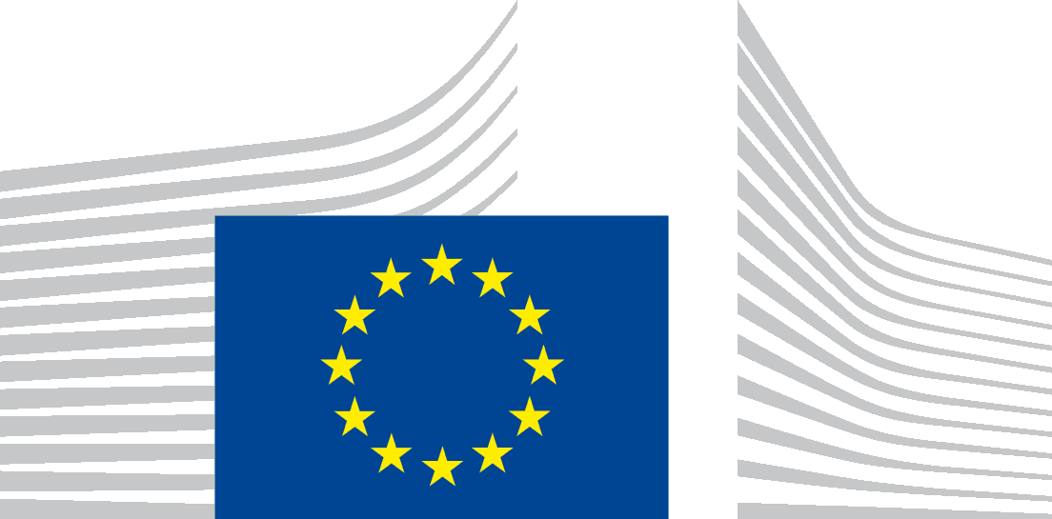 | EUROPEAN EDUCATION AND CULTURE  EXECUTIVE AGENCY (EACEA)
Brussels
EACEA.

MEDIA – TV and Online Content 2023 call for proposals info day

Data Protection Notice

The European Education, and Culture Executive Agency ("EACEA") is committed to preserving your privacy. All personal data are dealt with in accordance with Regulation (EU) No 2018/1725 on the protection of personal data by the Union institutions, bodies, offices and agencies ("the data protection regulation").

On 6 December 2022, EACEA is organising an info session for the MEDIA – TV and Online Content call for proposals. The following Data Protection Notice outlines the policies by which EACEA collects, manages and uses the personal data of the concerned individuals within the online event.
- Who is responsible for processing your personal data (data controller)?
The controller is the European Education and Culture Executive Agency, BE-1049 Brussels
The person designated as being in charge of the processing operation is the Head of Unit B2
Email: EACEA-MEDIA-TV@ec.europa.eu

- Which personal data are processed?
Mandatory data for the event organisation: none (Webex link to be circulated via CEDesks and anonymous participation).
Participants are encouraged to provide, to the extent possible, anonymised data to register to the event (corporate email address without name e.g. contact@companyname.com).
- For speakers: images and voice of the speakers as the event will be audio and video recorded, and images and video recordings of the event may be published on EACEA’s intranet webpage hosted on My IntraComm (the European Commission’s internal intranet), and EACEA website on EUROPA.

- For which purpose do we process your data?
Organising and managing the event: the primary purpose of the collection of personal data is for the organisation of the given event.
In addition, the purpose of the processing is also for:
- Recording of the event: the event will be audio and video recorded for the purpose of communication. We will record on video speakers’ presentations and their answers to participants’ questions. When asking questions, participants will be asked to use the chat function. If they nonetheless choose to ask questions using video and/or audio, participants will be recorded accordingly.
- Publication: images and video recordings of the speakers to the event (including speakers/moderators) and, if any, images and video recording of participants may be published on EACEA’s and / or the European Commission’s intranet and external websites, and the images in the recording can be used by the EACEA and the European Commission for communication purposes.

- Who has access to your personal data and to whom is it disclosed?
Access to your personal data may be given on a need-to know basis to the following recipients:
- EACEA: Staff members of the unit of the controller, Director and Heads of Department.
- European Commission: relevant DGs in particular the Directorate-General for Education, Youth, Sport and Culture (DG EAC), Directorate-General for Communications Networks, Content & Technology (DG CNECT).
- Webex will process your data for the purpose of organising and managing the event.

In case of control or dispute, the bodies charged with a monitoring or inspection task in application of Union law (e.g. Internal Audit Service, European Commission, OLAF, EU Courts etc.).
Upon consent of the data subjects:
- General public: whilst publishing the video and audio recording, participants’ personal data appearing on the recording (face, voice, presenters’ contribution) will be published on the websites and intranet of EACEA and the European Commission. Participants are invited to switch off their micro and camera if they do not want to appear in the recording

Use of a video conferencing tool/third party tool: please note that the event will be organised using Webex, which has a contract with the European Commission. Your personal data used for your participation to the event will also be processed by this tool and transferred outside the EU/EEA, in accordance with its privacy policy which can be found here: https://ec.europa.eu/info/files/web-conference-privacy-statement_en. Such transfer will be made based on standard contractual clauses as part of a contract between the service provider and the European Commission. You can obtain more information on it by contacting the data controller at the above mentioned email address.
- How long do we keep your personal data?
Video and audio recording will be published on the intranet/website of EACEA/EC during a maximum of 2 months after the event, and further kept for 2 years after the date of event.

- What are your rights concerning your personal data and how can you exercise them?
Under the provisions of the data protection regulation, you have the right to:
- Request to access the personal data EACEA holds about you;
- Request a rectification of your personal data where necessary;
- Request the erasure of your personal data;
- Request the restriction of the processing of your personal data;
For the processing of your personal data which is based on public interest under of Article 5(1)(a) of the data protection regulation, please note that you have the right to object to processing of your personal data on grounds relating to your particular situation under the provisions of Article 23 of the data protection regulation.
For the processing of your personal data which is based on your consent under Article 5(1)(d) / 50(1)(a) of the data protection regulation, please note that you can withdraw it at any time, and this will have effect from the moment of your retraction. The processing based on your consent before its withdrawal will remain lawful.
You should also be informed that by virtue of Article 25 of the data protection regulation and of the Internal Rules laid down under Decision of the Steering Committee on internal rules concerning restrictions of certain rights of data subjects in relation to the processing of personal data in the framework of activities carried out by the European Education and Culture Executive Agency dated 22 October 2020 (published on the Official Journal: https://eur-lex.europa.eu/legal-content/EN/TXT/?uri=CELEX:32021Q0317%2801%29), one or several of these rights may be restricted for a temporary period of time inter alia on the grounds of prevention, investigation, detection and prosecution of criminal offences.
- Your right to have recourse in case of conflict on any personal data issue
In case of conflict on any personal data protection issue you can address yourself to the Controller at the above mentioned contact details.
You can also contact the Data Protection Officer of EACEA at the following email address: eacea-data-protection@ec.europa.eu.
You may lodge a complaint with the European Data Protection Supervisor at any time: http://www.edps.europa.eu.
- On which legal basis are we processing your personal data?
The Processing of your personal data is based on the following legal basis:
Art. 5(1)(a) processing is necessary for the performance of a task carried out in the public interest or in the exercise of official authority vested in the Union institution or body (to be laid down in Union Law):
- For collecting and processing your data for the purpose of organising and managing the event. Provision and processing of these personal data is mandatory to attend to the event (for speakers). For the general public, they can join the event anonymously and use the chat function for questions/inputs without sharing personal data.
- For processing of your personal data via the above mentioned third party tool(s) used to organised the event
- For audio and video recording of the event.

The applicable legal basis under Art. 5(1)(a) are:
- The Commission Implementing Decision 2021/173 establishing the European Education and Culture Executive Agency;
- The Commission Decision C(2021)951 and its annexes delegating powers to EACEA for the management of programmes in the MFF 2021-2027.
- Regulation (EU) 2021/818 of the European Parliament and of the Council of 20 May 2021 establishing the Creative Europe Programme (2021 to 2027) (OJ L 189, 28.5.2021, p. 34)

Art. 50(1) (a) the data subject has given consent to the processing of his or her personal data for one or more specific purposes
- Publication on the Internet/Intranet of the Audio and Video recording of the event on EACEA website.

For speakers: If you do not want your personal data appearing into the audio and video recording being published, you can freely refuse to do the presentation, or decide to do the presentation while keeping your camera switched off.

For the participants: If you do not want your personal data be processed by and transferred to the third party tool, including to be recorded and published, you can also decide to enter non-personal data when registering to the tool used for the event, and to keep your camera and microphone switched off during the event.

Regulation (EU) 2018/1725 of the European Parliament and of the Council of 23 October 2018 on the protection of natural persons with regard to the processing of personal data by the Union institutions, bodies, offices and agencies and on the free movement of such data, and repealing Regulation (EC) No 45/2001 and Decision No 1247/2002/EC Text with EEA relevance, OJ L 295, 21.11.2018, p. 39.

